**TASK 1 – Update options in DB from full major string values to abbreviated major values**

1. Tables

As you can see in the below tables, I have updated the persistence of the major field from a full string value to that of an abbreviated version.

1. Proj2Appointments

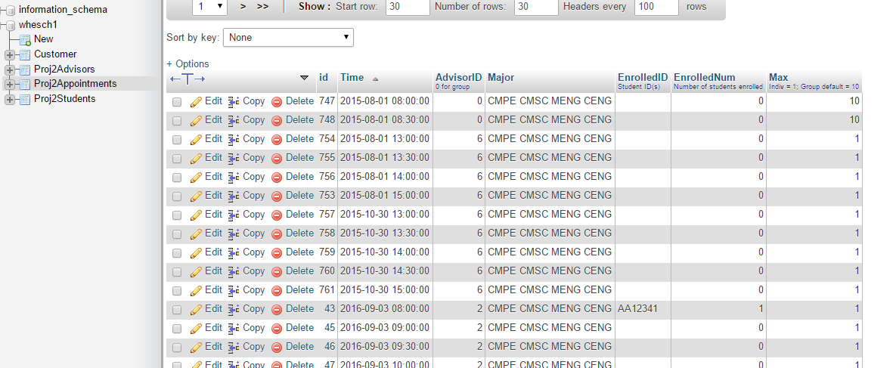

1. Proj2Students

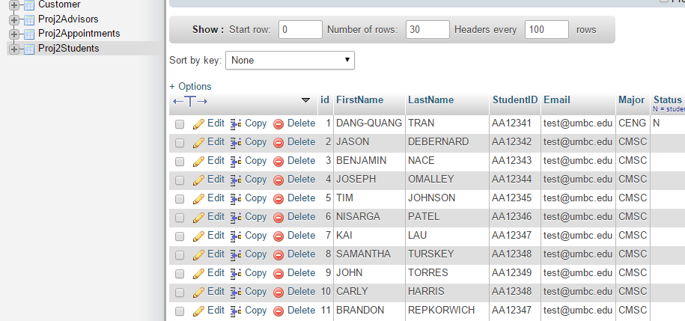

1. Code

Likewise, in code, I had to handle the abbreviated major in a minimum of two places. When reading data from the database, we would have to convert the data prior to printing it on the screen. When attempting to insert the data in the database from user selections, we would need to do a similar conversion.

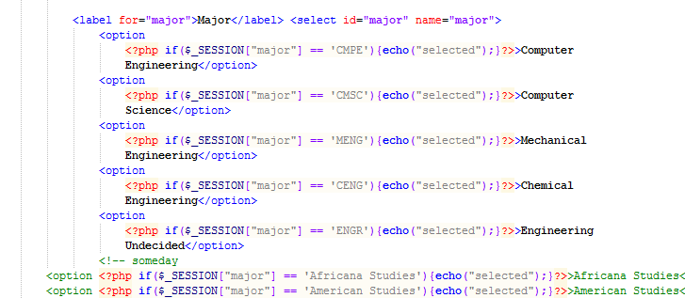

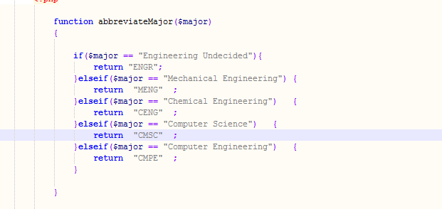

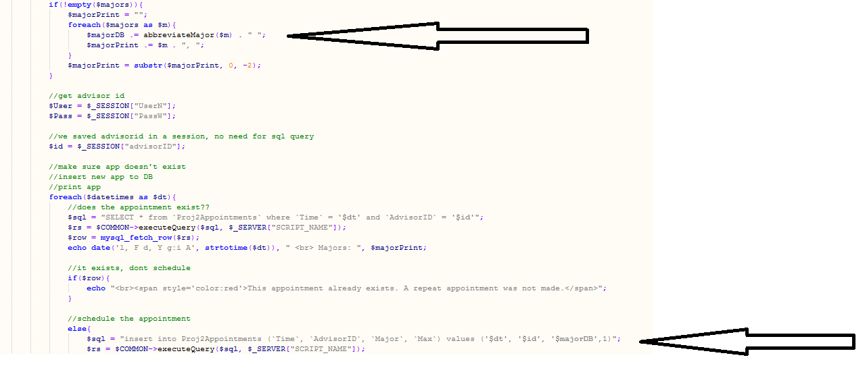

**TASK 2 – Display where office advisers are located when viewing appointments.**

1. Tables

As you can see in the below table, I have updated the persistence of the advisor table to include a column for office number

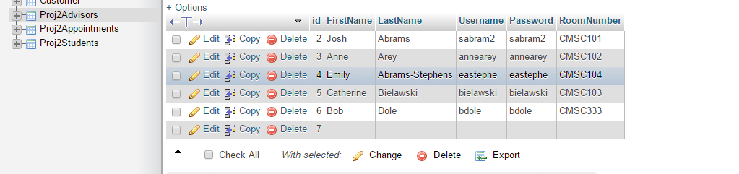

1. Code

Likewise, in code, I had to remember to both insert the room number when entering a new advisor as well as select the room number to display it when viewing appointments

